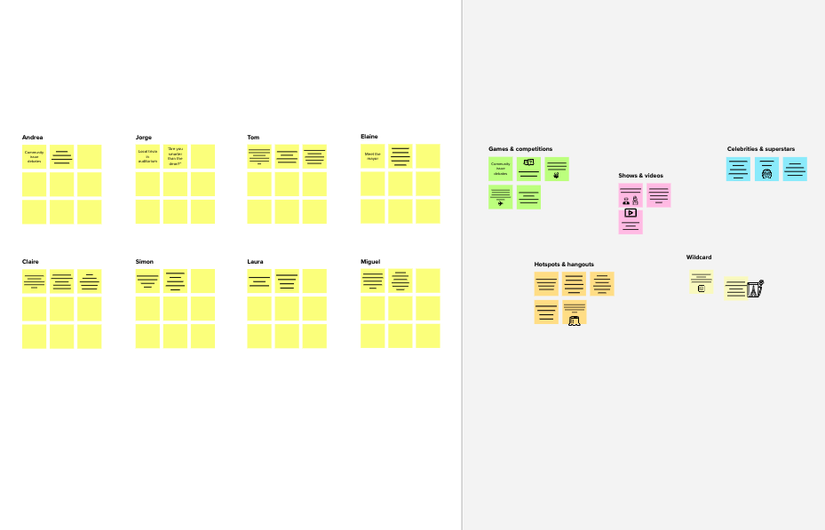

**Brainstorm**

**& idea prioritization**

Use this template in your own brainstorming sessions so your team can unleash their imagination and start shaping concepts even if you're not sitting in the same room.

**10 minutes** to prepare

**1 hour** to collaborate

**2-8 people** recommended

[**Share template feedback**](https://muralco.typeform.com/to/CiqaHVat?typeform-source=app.mural.co)

**Need some inspiration?**

See a finished version of this template to kickstart your work.

[**Open example**](https://app.mural.co/template/e5a93b7b-49f2-48c9-afd7-a635d860eba6/93f1b98d-b2d2-4695-8e85-7e9c0d2fd9b9)



**3**

**Group ideas**

Take turns sharing your ideas while clustering similar or related notes as you go. In the last 10 minutes, give each cluster a sentence-like label. If a cluster is bigger than six sticky notes, try and see if you and break it up into smaller sub-groups.

**20 minutes**

**4**

**Prioritize**

Your team should all be on the same page about what's important moving forward. Place your ideas on this grid to determine which ideas are important and which are feasible.

**20 minutes**

**TIP**

Add customizable tags to sticky notes to make it easier to find, browse, organize, and categorize important ideas as themes within your mural.

**Signaling**

**Friction technology**

**Tracking sysrtem**

**Traffic data**

**Train control sysytem**

**Smart sensors**

**Train control system**

**Tracking system**

**Friction technology**

**Smart sensors**



**After you collaborate**

You can export the mural as an image or pdf to share with members of your company who might find it helpful.

**Quick add-ons**

**A**

**Share the mural**

**Share a view link** to the mural with stakeholders to keep them in the loop about the outcomes of the session.

**B Export the mural**

Export a copy of the mural as a PNG or PDF to attach to emails, include in slides, or save in your drive.

**Keep moving forward**

**Strategy blueprint**

Define the components of a new idea or strategy.

[**Open the template**](https://app.mural.co/template/e95f612a-f72a-4772-bc48-545aaa04e0c9/984865a6-0a96-4472-a48d-47639307b3ca)

**Customer experience journey map**

Understand customer needs, motivations, and obstacles for an experience.

[**Open the template**](https://app.mural.co/template/b7114010-3a67-4d63-a51d-6f2cedc9633f/c1b465ab-57af-4624-8faf-ebb312edc0eb)

**Strengths, weaknesses, opportunities & threats**

Identify strengths, weaknesses, opportunities, and threats (SWOT) to develop a plan.

[**Open the template**](https://app.mural.co/template/6a062671-89ee-4b76-9409-2603d8b098be/ca270343-1d54-4952-9d8c-fbc303ffd0f2)

[**Share template feedback**](https://muralco.typeform.com/to/CiqaHVat?typeform-source=app.mural.co)

Template



**Before you collaborate**

A little bit of preparation goes a long way with this session. Here’s what you need to do to get going.

**10 minutes**

**A Team gathering**

Define who should participate in the session and send an invite. Share relevant information or pre-work ahead.

**B Set the goal**

Think about the problem you'll be focusing on solving in the brainstorming session.

**C Learn how to use the facilitation tools**

Use the Facilitation Superpowers to run a happy and productive session.

[**Open article**](https://support.mural.co/en/articles/2113740-facilitation-superpowers)

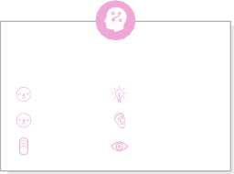

**1**

**Define your problem statement**

What problem are you trying to solve? Frame your problem as a How Might We statement. This will be the focus of your brainstorm.

**5 minutes**

**Key rules of brainstorming**

To run an smooth and productive session

Stay in topic.

Encourage wild ideas.

Defer judgment.

Listen to others.

Go for volume.

If possible, be visual.

**PROBLEM**

Train accidents? solution:

1. automatic gate control
2. continous railway track monitoring



**2**

**Brainstorm**

Write down any ideas that come to mind that address your problem statement.

**10 minutes**

**TIP**

You can select a sticky note and hit the pencil [switch to sketch] icon to start drawing!

**MUSTHA**

**SANHAR**

**FAIZAL**

**SULPIKAR**

**Feasibility**

Regardless of their importance, which tasks are more feasible than others? (Cost, time, effort, complexity, etc.)

**Importance**

If each of these tasks could get done without any difficulty or cost, which would have the most positive impact?

**TIP**

Participants can use their cursors to point at where sticky notes should go on the grid. The facilitator can confirm the spot by using the laser pointer holding the **H key** on the keyboard.

**Signaling**

**Sound energy**

**Wire base station**

**Wayside server**

**Train control system**

**Customer experience**

**Protocol system**

**Basic radio unit**

**Data link**

**Active shift to rail**

**Friction technology**

**Receive Data**

**Electric design**

**Global tracking**

**Passenger experience**

**Tracking system**

**Passenger experience**

**Traffic data**

**Less maintenances days**

**Delay management**

**smart sensors**

**Improve communication**

**Time table planning**

**Mechanical system**